Group-6
Book Management System

TEAM
103111 V.V.B.Sravya (Group Lead)
103205 Sai Prathap Reddy
103331 Sai Priyanka Botta
103324 Santosh Jayendra Sai Dama
103323 Sathish Kumar Reddy Pagidi
103366 Sreeramoju Sai Rathan
103256 Sandhya Chauhan

The following are the screenshots for the output of Forms and Reports for Book Management System:

- Author Master Form

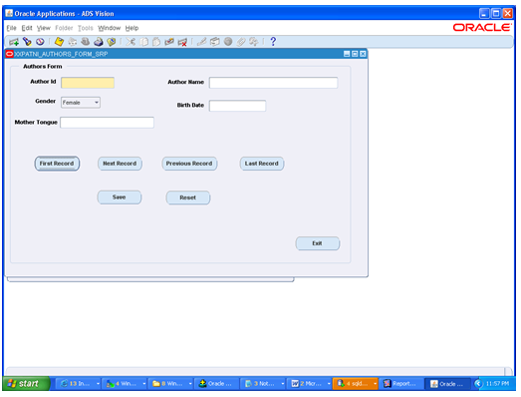

- Book Master Form
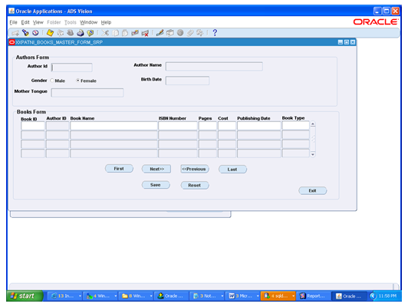

- Books Database

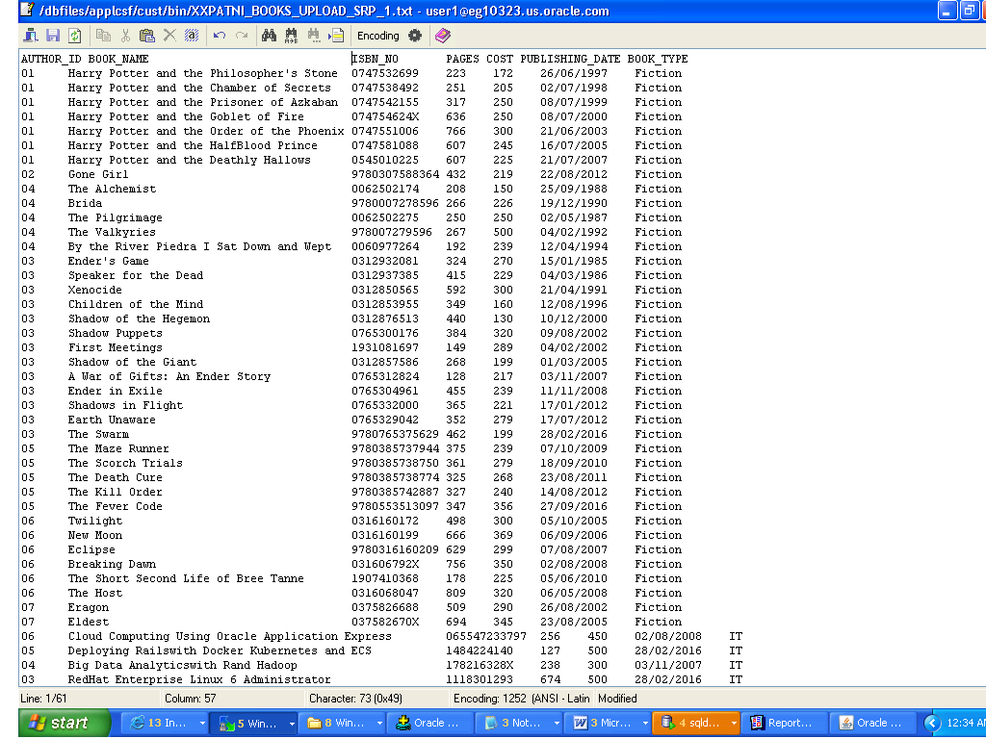

- Books Upload Control File

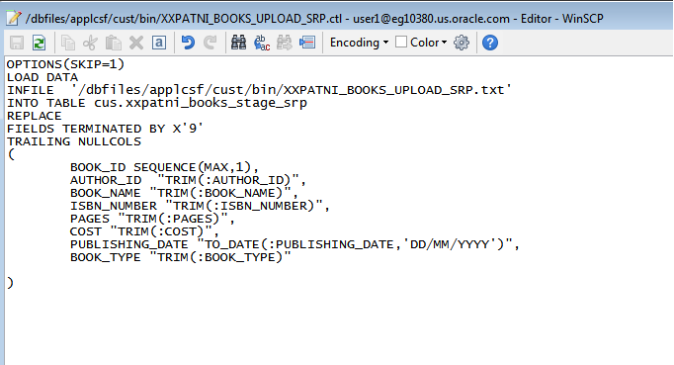

- Authors Database

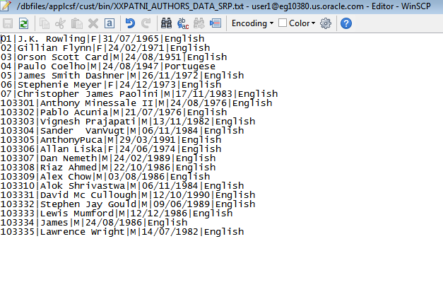

- Authors Upload Control File

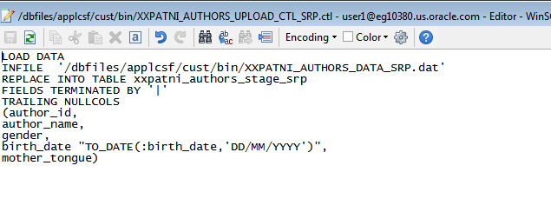

- Report Data Model

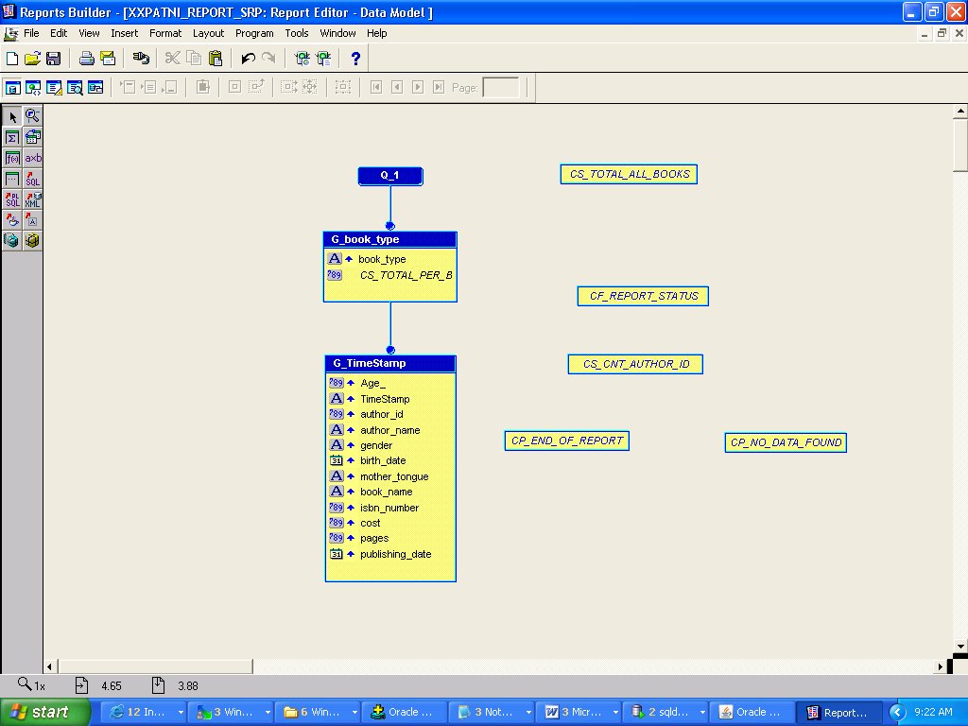

- XML Generated File

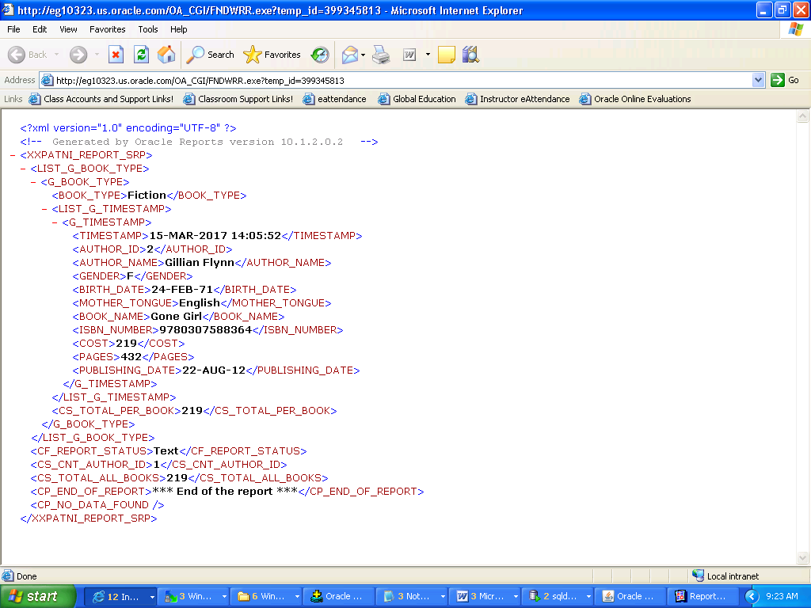

- RTF File

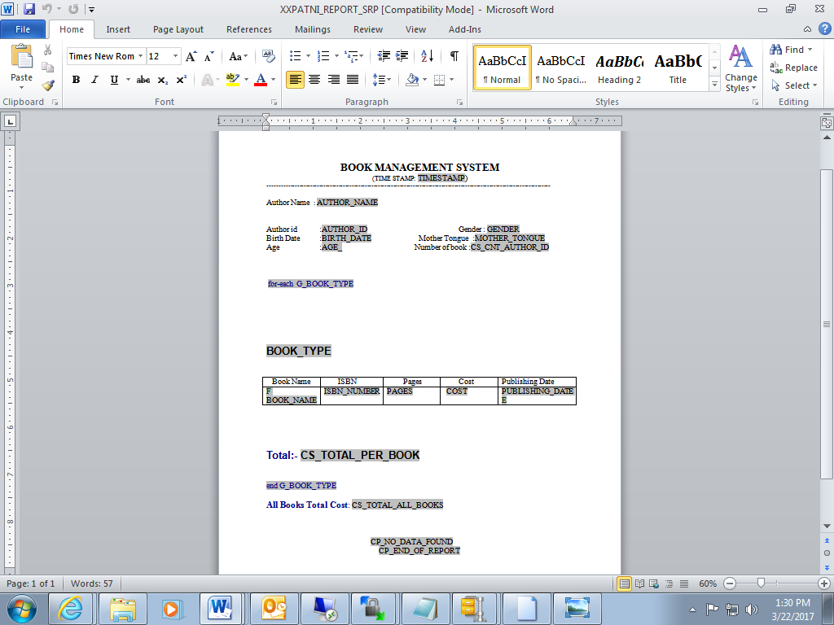

- Generated Report For Output

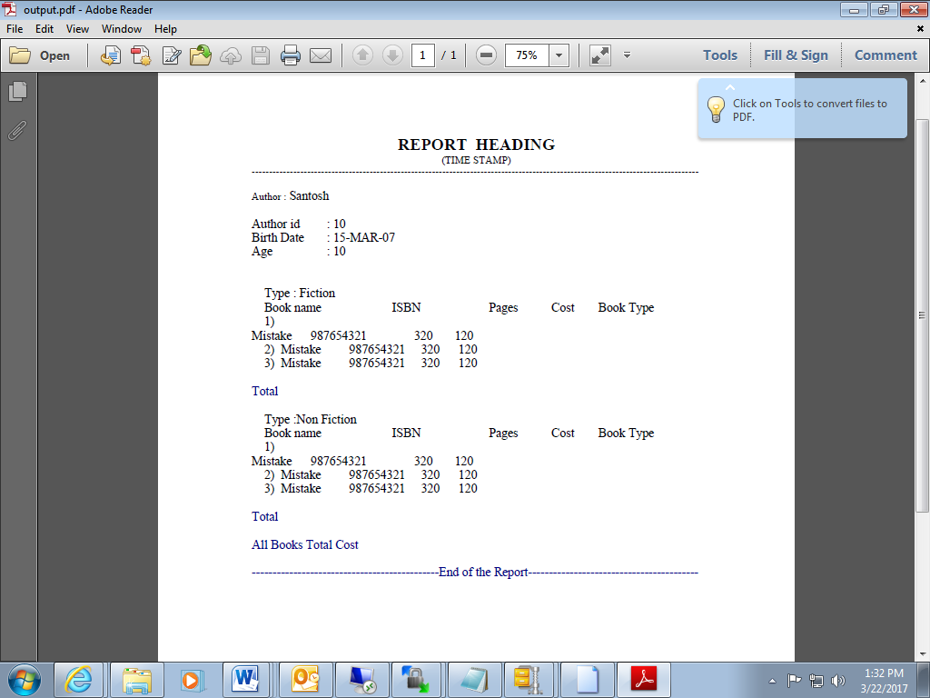

- Generated Report For Output – End Of the Report

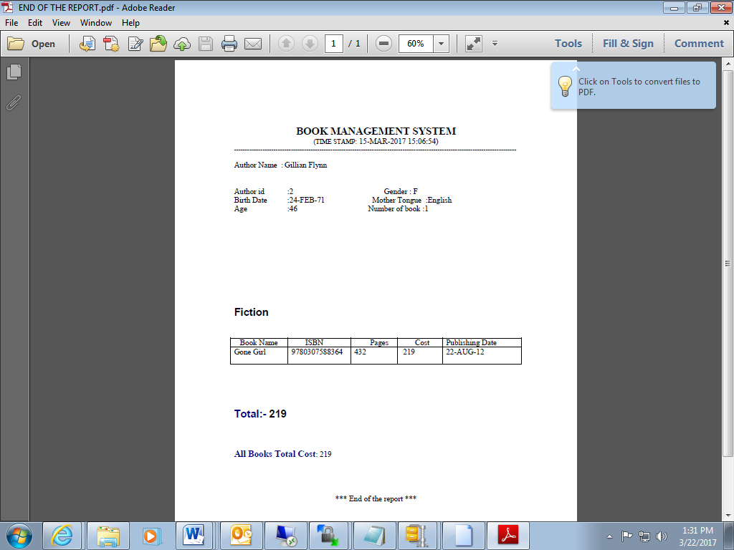

- Generated Report For Output- No Data Found

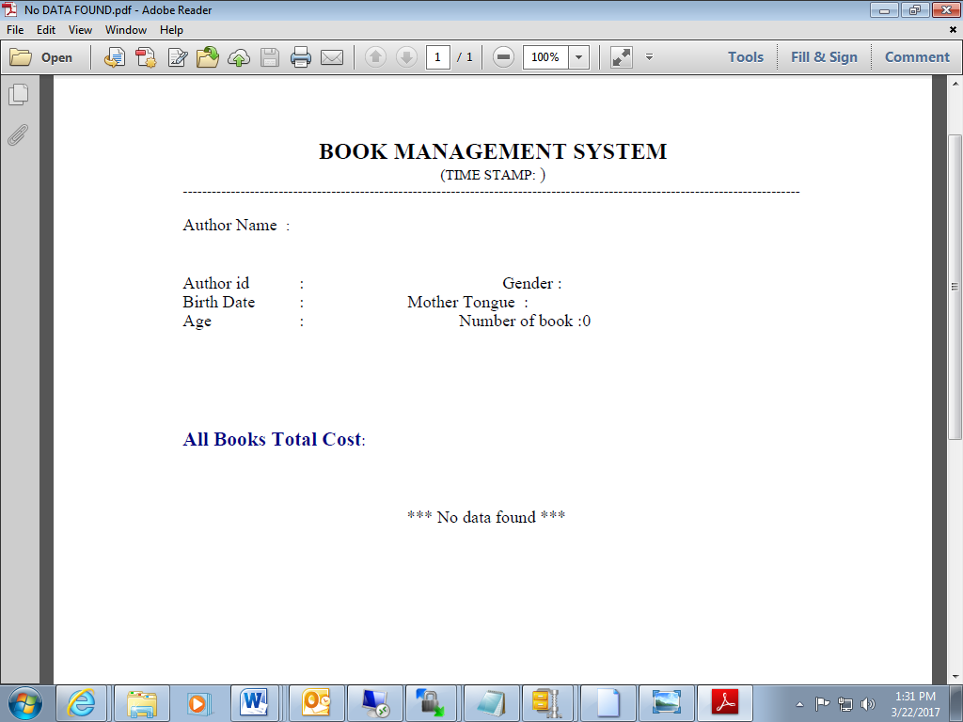

- Future-Scope – With Check-boxes for data filteration

